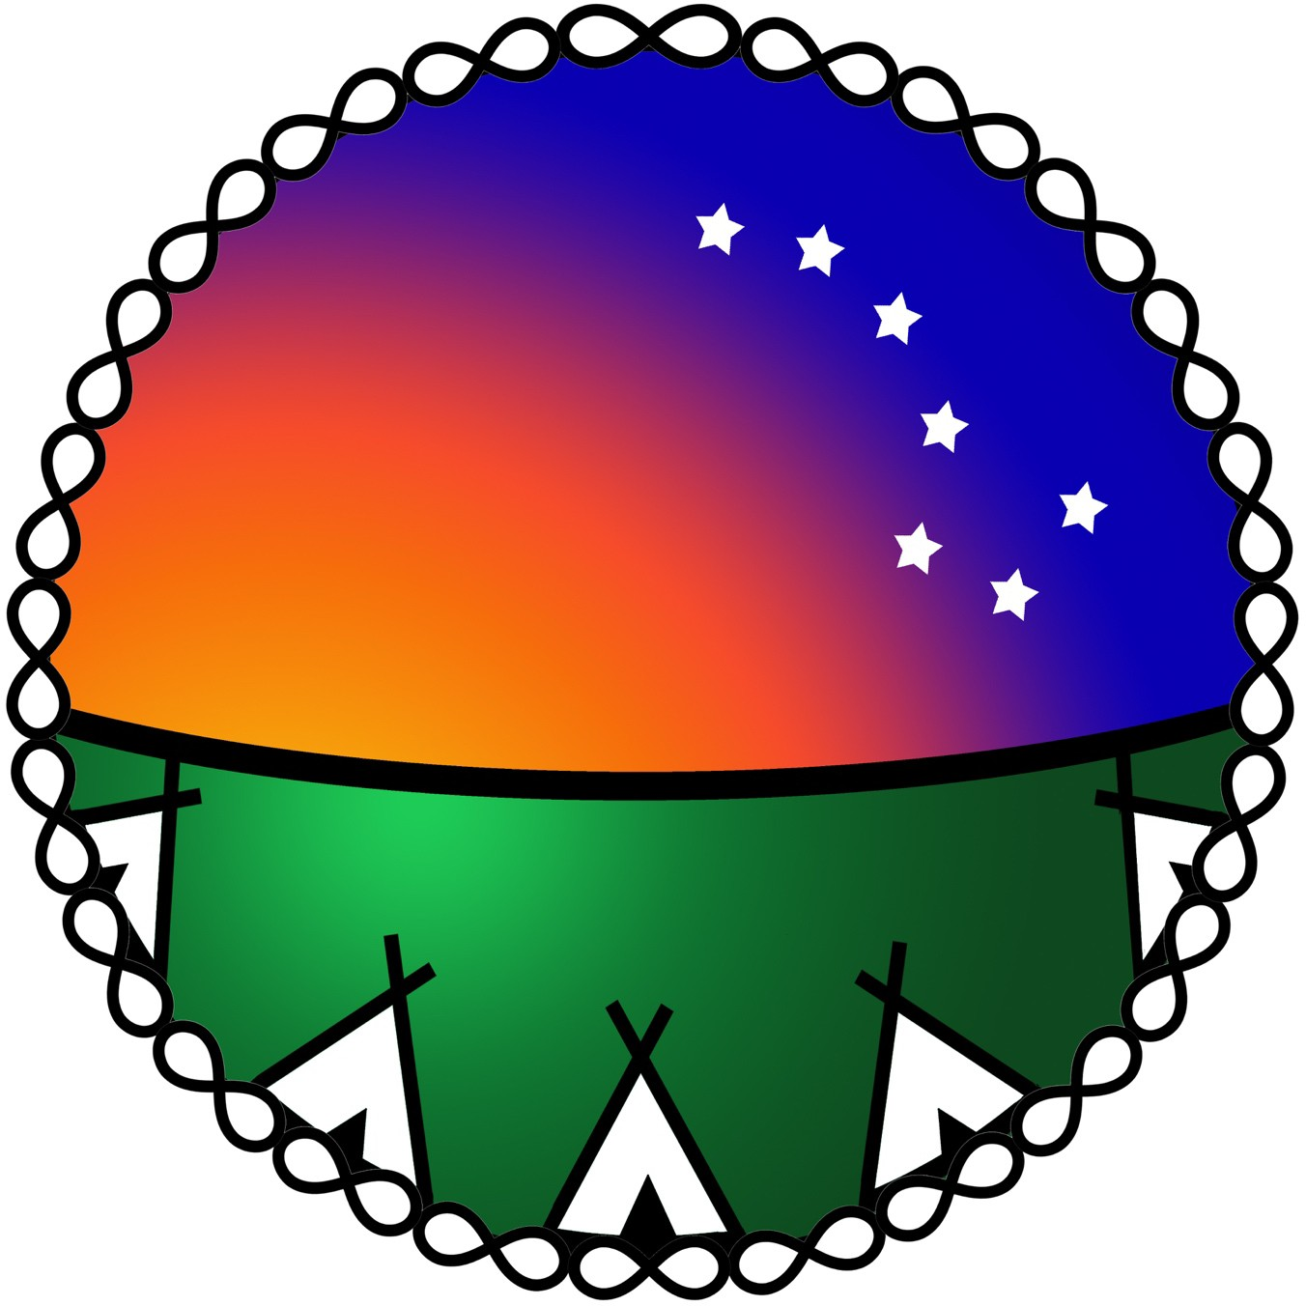
Alberta Indigenous Mentorship in Health Innovation (AIM-HI) Network and the Population, Public and Indigenous Health Strategic Clinical Network (PPIHSCNTM)

First Nations, Métis and Inuit Graduate Student

Experiential Internship Opportunity

Please complete this application form, and submit it along with your CV to aimhi@ucalgary.ca
Your Name:
Your Email:
Indigenous Community:
Current Training Program and Location:
Graduate Degree and Date of Completion:

Provide 1 paragraph statements (maximum 200 words each to summarize your experience in:
- Program Evaluation
- Indigenous engagement
- Indigenous research methods
- Western research methods

