APPENDIX II: Fixed Gas Detection Notification, Specifications & Operational Parameters
 | Name: |  |  | Office Phone: |  |  |  | Alternate Phone:
Main Contact:
Alternate Contact:
Building & Rm #: |  |  |  |  | Gas of concern:
Room Type or Equipment:
Sensor # & type: |  |  |  |  | Sensor # & type:
Manufacturer:
Calibration gas:
Calibration schedule (as per manufacturer or Facilities requirements):
Records for the detection system are to be maintained in the area log book and in FM&D records.

Local Alarm (warning)  10% of xxxx for xxxx | Activated at xxxx ppm or xxxx %  Displays as 10%
Local Visual  e.g. flashing blue light within the work space | Insert location and type of visual device
Local Audio  e.g. six second tone, buzzer | Insert description and location of the type of audio device
Ventilation system  e.g. supplemental exhaust ventilation increases air changes per hour | Insert description of operational sequence of ventilation system
Alarm notification  e.g. trouble alarm sent to fire panel and/or to BMS | Insert description of the type of signal sent
Building Alarm (evacuation)  (no building evacuation for oxygen sensors)  20% of xxxx for xxxx | Activated at xxxx ppm or xxxx %  Displays as 20%
Building Visual (building fire alarm)  e.g. strobe and a flashing blue light outside but adjacent to the work space | Insert description of the type of visual device
Building Audio (building fire alarm)  e.g. tone, buzzer | Insert description of the type of audio device
Ventilation system  e.g. supplemental exhaust ventilation increases air changes per hour | Insert description of the what actually happens to the ventilation system
Alarm notification  e.g. evacuation alarm sent to fire panel and to BMS | Insert description of the type of signal sent
Auxiliary System  e.g. automatic gas shutoff | Insert description of the auxiliary system

Example:
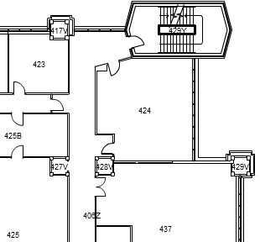
Legend:
Location of sensor
Location of display panel

