User Guide to the COVIDSafe Campus web platform – Hosted by Thrive Health

Instructions for users with a non UCalgary email addresses

Mandatory

- Creating your account
- Completing your Vaccination Attestation Form

You are exempt from Steps 3-5 if you are not coming to campus or have declared full vaccination

- Completing your COVID-19 Self-Assessment
- Scheduling an appointment
- Reporting Self-Administered Rapid Screening Tests

Click here for FAQ information on the UCalgary COVIDSafe Campus Strategy

Mandatory

- Creating your account

- You will receive an email from Thrive Health on behalf of the University of Calgary inviting you to join.
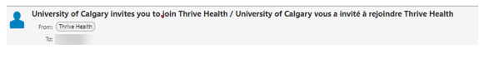
- Click on “Get Started”
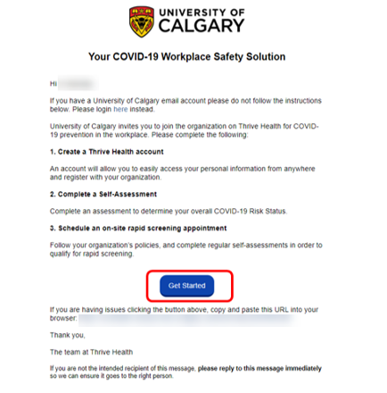

- Create a password and confirm it
- Read and agree to the Privacy Policy Terms of Use
- Click on “Create Account”
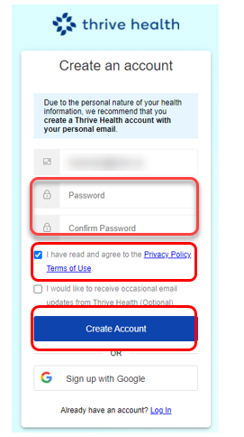

Please do not use:

Sign up with Google
or
Sign Up Account

  - Select your preferred language, and click on “Confirm”
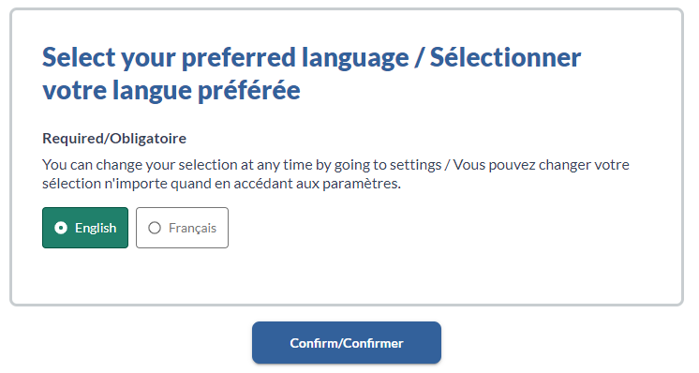

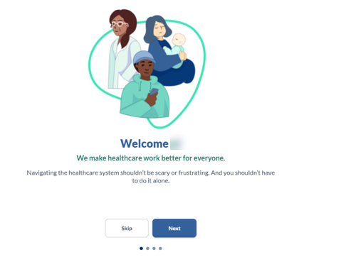
- You will see a series of marketing screens from Thrive Health, you can see them by clicking on “Next” or skip them by clicking on “Skip”

- Review and “Confirm”
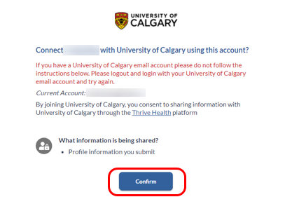

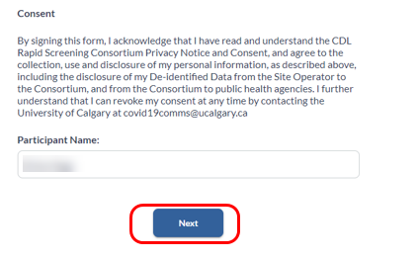
- Read and sign the consent with your name and last name and click on “Next”

- Enter the last 4-digits of your phone number. If the last 4 digits of your phone number do not match the phone number on record, please contact UService at (403) 220-8366 for instruction on how to proceed with your registration.
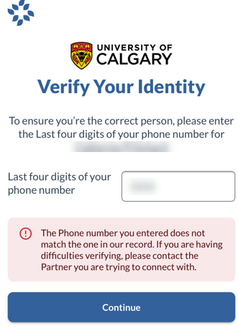
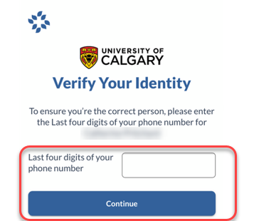

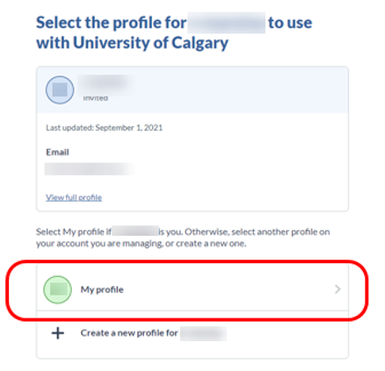
- Select the profile you just created by clicking on “My profile”

- Create your University of Calgary profile
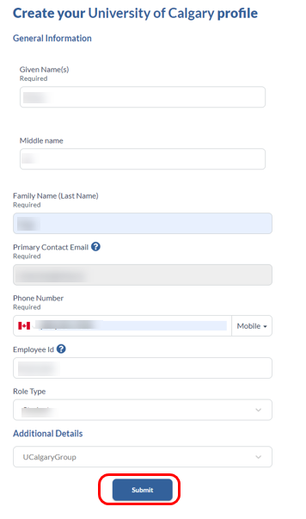

Mandatory

- Completing your Vaccination Attestation Form

- Click “Complete your vaccination attestation form”
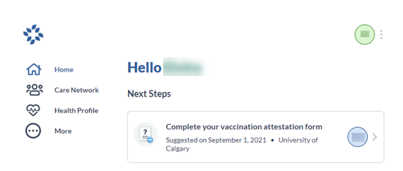

- Answer whether you will be attending the University of Calgary in person between now and Dec. 31, 2021 and click “Submit.” If the answer in No, no further action is required.
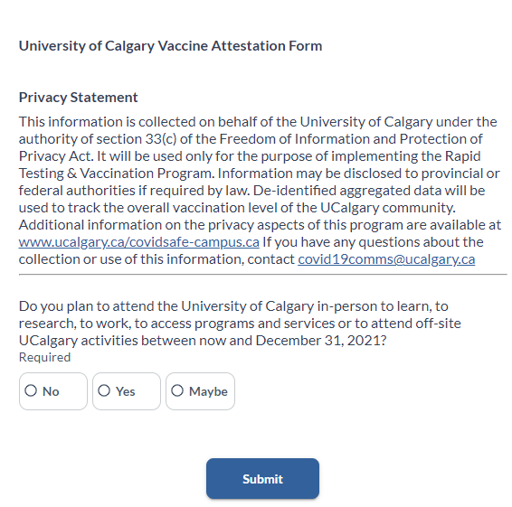

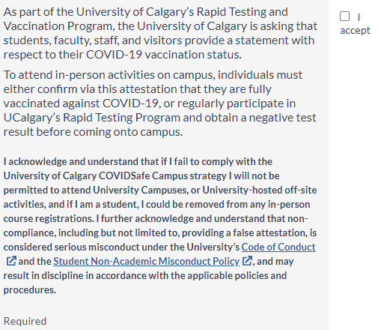
- If the answer is YES or MAYBE, an agreement statement will appear. Read and accept the agreement by clicking “I accept.”

- Now it is time to declare your vaccination status and click “Submit.” If you answer “Yes”, no further action is required.
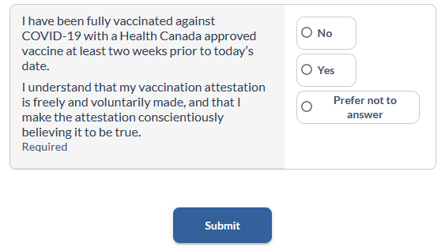

- If you answer No or Prefer not to answer, the following message box will appear requesting self-assessment and rapid testing. Click “Submit.” You will be redirected to the user homepage, and you will receive an email confirming the completion of the form.
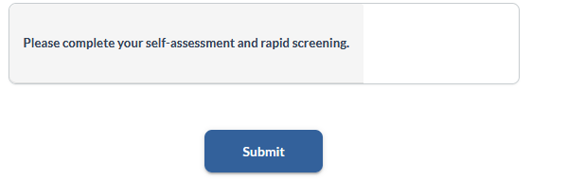

- To view your completed tasks:
On a laptop/computer device | On a smart device
Click on “Care Network.”  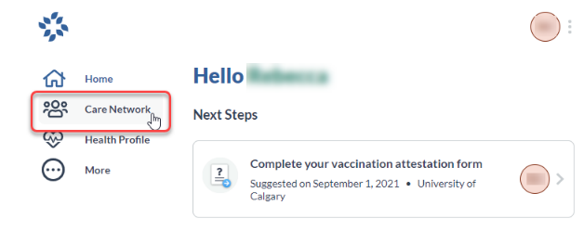 | Click on “COVID-19 Health Centre”  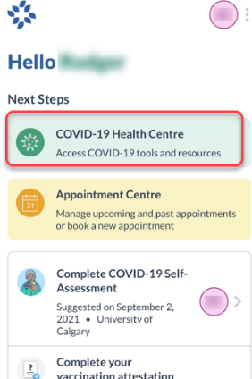
Click on “University of Calgary Vaccine Reporting Journey.”  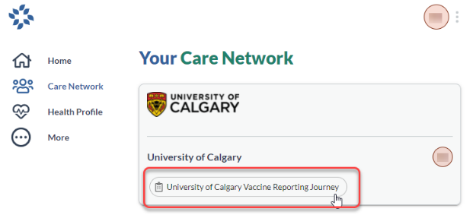 | Click “Care Network” found in the mobile menu located at the bottom of your screen. Allow for a couple of seconds for the menu to appear.  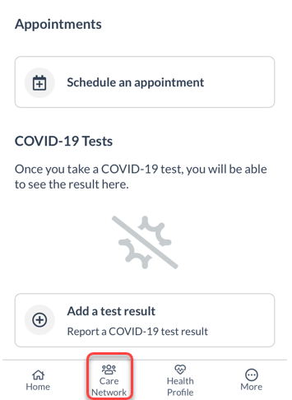

You are exempt from Steps 3-5 if you are not coming to campus or have declared full vaccination

- Completing your COVID-19 Self-Assessment

- On the user homepage, click “Complete COVID-19 Self-Assessment.”
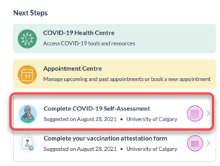

- You will be directed to the Self-Assessment page. Answer all the questions as prompted.
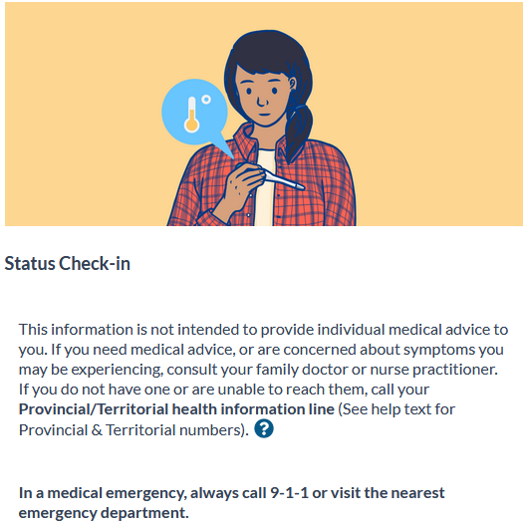 | 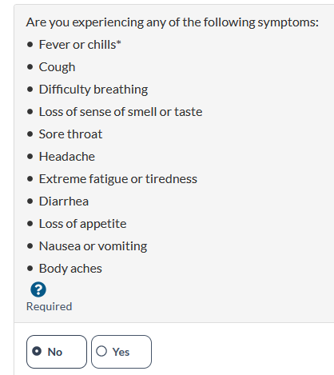 | 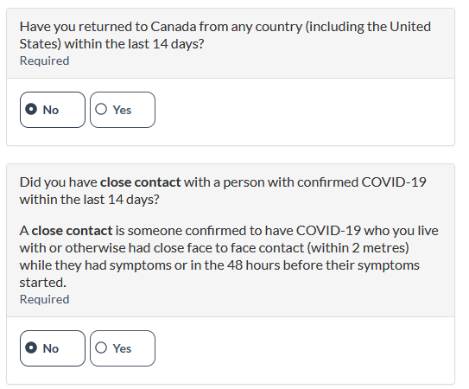

- If you answer all the questions “No” you will be given a “green” status. You now may proceed to book an appointment to pick up your rapid testing kits on campus. When you complete the self-administered tests, you will need to upload the results by a specified date.
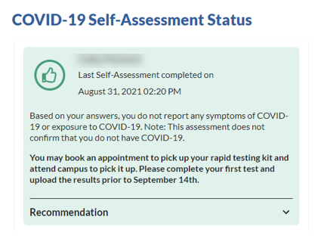

- If you answer “Yes” one or all the questions “No,” you will be given a “red” status.
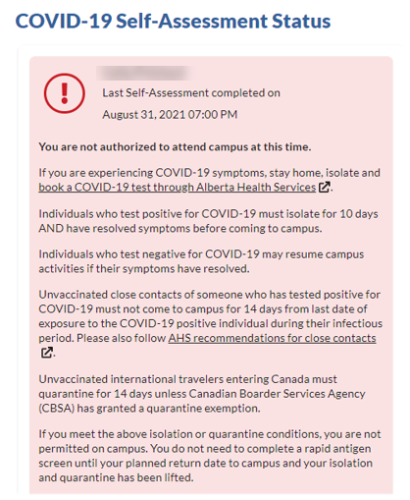

You are exempt from Steps 3-5 if you are not coming to campus or have declared full vaccination

- Scheduling an Appointment

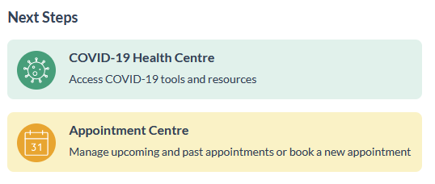
- On the user homepage, click “Appointment Centre.”

- Click on “Book new appointment.”
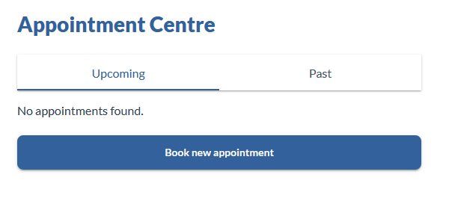

- Select the location for pick up.
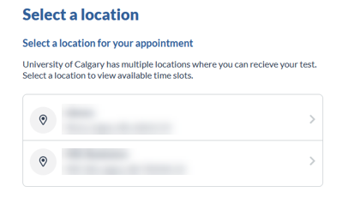

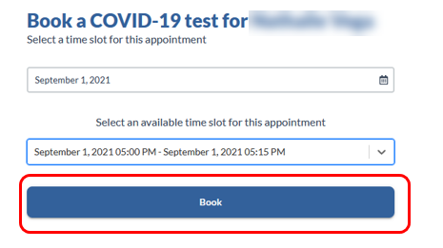
- Select date and time and click “Book.”

- You will see the confirmation and QR code you need to present when picking up the rapid tests. You will also receive a confirmation email. The email may not have the code. Please take a screen shot of your QR code to take with you to your appointment.
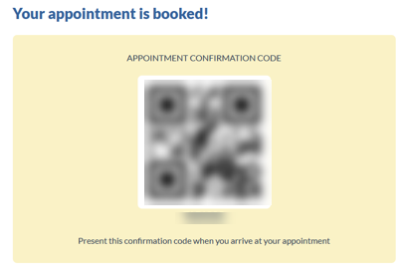

- Click on “Return to Appointment Centre”. Now you will see your appointment listed.
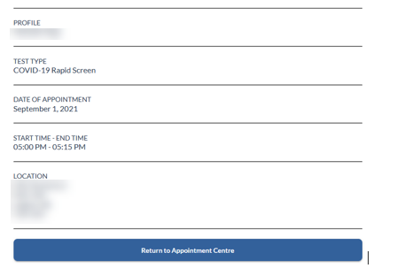 | 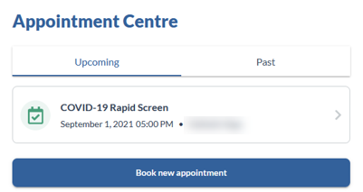

- If you need to cancel or modify your appointment, click on the appointment.
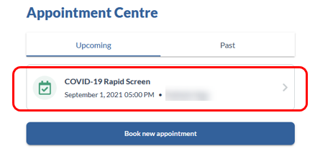

- At the bottom of the screen, you will find the options for cancelling or rescheduling.
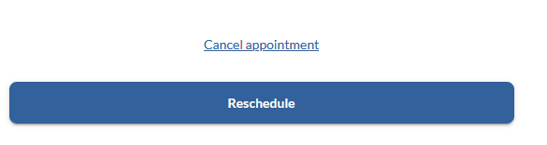

You are exempt from Steps 3-5 if you are not coming to campus or have declared full vaccination

- Reporting Self-Administered Rapid Screening Tests

- Once you have completed your self-administered COVID-19 rapid screening test, take a clear photo of your test kit result.

- Go to the user home page and click on COVID-19 Health Centre.
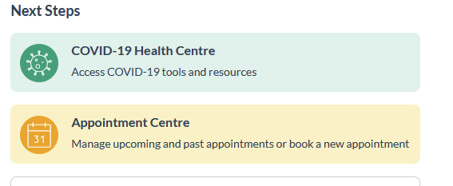

- Go to the bottom of the screen and click on “add a test result.”
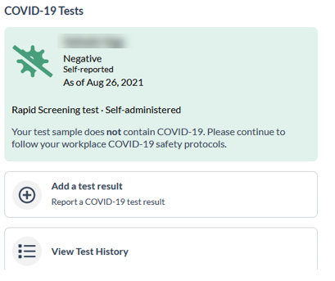

- Select the type of test, click on Self-administered Rapid Screening Test.
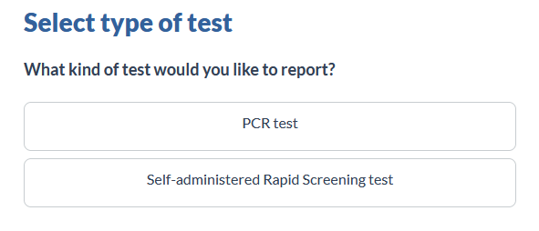

- Fill in the test details.

Negative Test Result
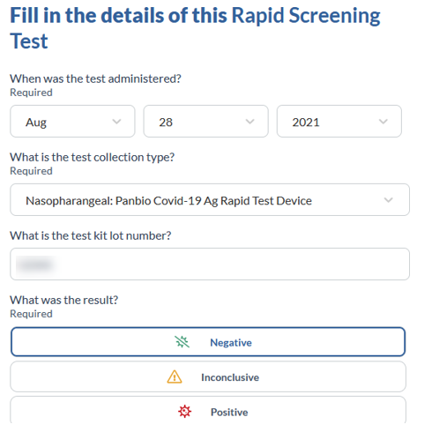 | 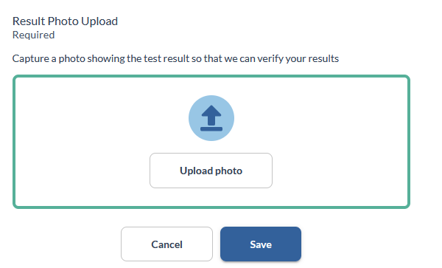

- Click on “upload photo” and select the picture from your computer or phone. As per the instructions included with your test kit, please ensure the photo you upload as the date written on it with the provided Sharpie marker.

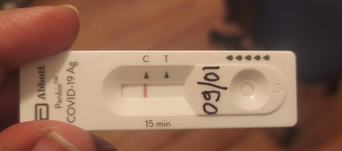
- The picture will show on the screen, click “Save.”

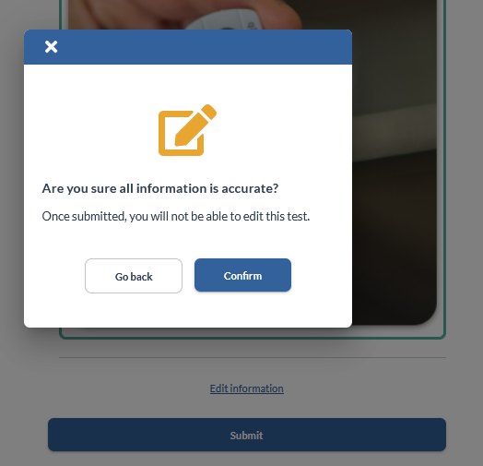
- Click “Submit “and “Confirm” that the information is accurate.

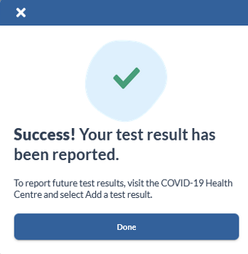
- Click “Done” and you will be redirected to the COVID-19 Health Centre.

- Results
Negative Test Result:

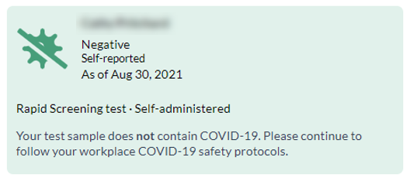
If the test is negative, follow all UCalgary COVID-19 safety protocols and submit another test in 3.5 days.

Inconclusive Test Result:
If your result is inconclusive or you are unsure of the result, please perform another test as soon as possible.
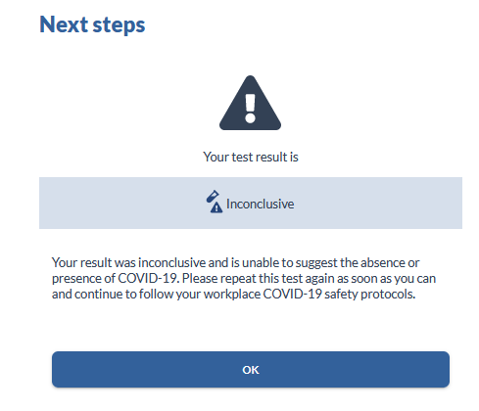
If you obtained two consecutive inconclusive rapid screen test results, please contact ohn@ucalgary.ca.
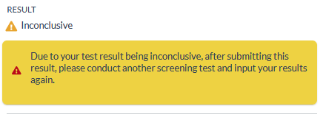

Positive Test Result:
If this test result is from a self-administered rapid screen test, use the AHS Online Booking Portal to arrange for a PCR test.
DO NOT come to campus. You will need to stay home and self-isolate for 10 days AND until symptoms resolve.
If you receive a positive PCR test, continue to isolate as directed above. Please also notify ohn@ucalgary.ca of your positive test result.
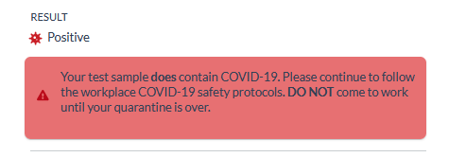
If you receive a negative PCR test, you may return to campus if you are not ill.

