Nasal Swab for COVID-19 Rapid Testing – Self Testing

TEST KIT CONTENTS
Each test kit will come with the following items:
Testing Devices | 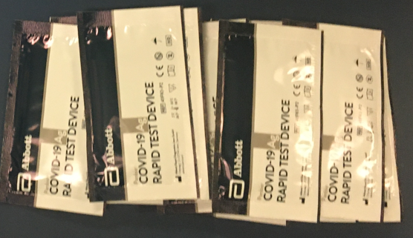  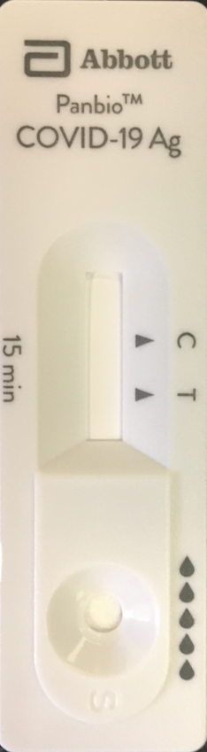
Extraction Tubes | 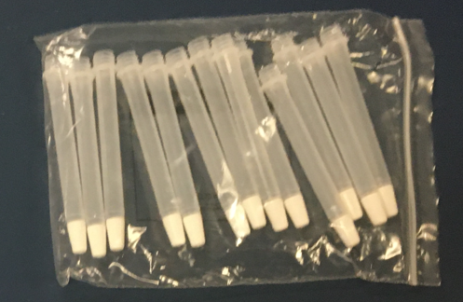
Extraction Tube Caps | 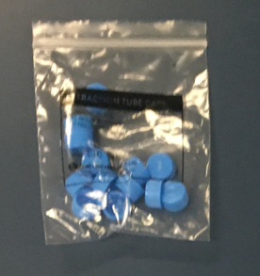
1 Buffer Solution Bottle  Note: One bottle will be sufficient for all the testing devices you receive | 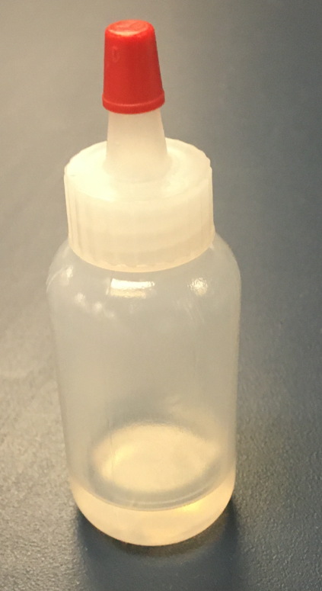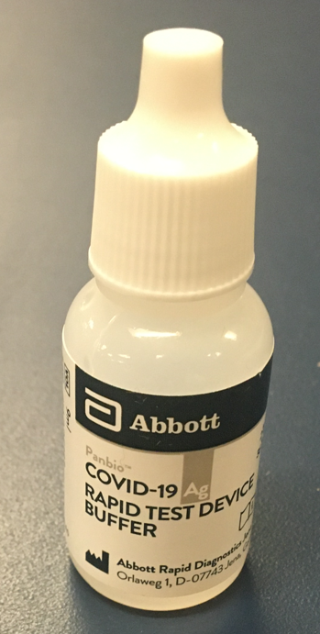
Sterilized Nasal Swabs | 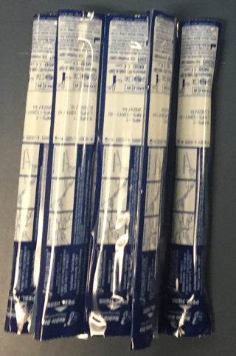

*Note: Test kits which have a Dec 2021 expiry date have been approved for use to Dec 2022.

TEST PREPARATION
- Allow all kit components to reach a temperature between 15-30°C prior to testing for 30 minutes
- Open the foil pouch and look for the following:
  - Result window
  - Specimen well
Then using a sharpie, label the device with the date MM-DD

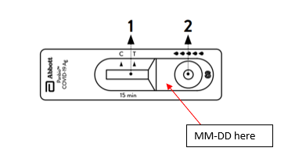

TEST PROCEDURE
- Wash your hands
- Hold the buffer bottle vertically and fill the extraction tube with buffer fluid until if flows up to the Fill-Line.
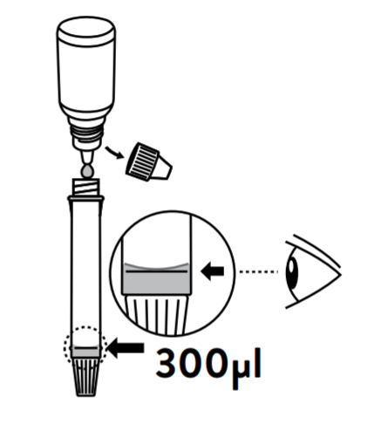
Caution! If the amount of buffer is insufficient or excessive, an improper test result may occur

- Remove the swab from the package and insert it about 2 cm (1 inch) into the nostril. Gently squeeze the nostril to improve the surface contact. Rotate swab five times. Using the same swab, repeat the collection procedure with the second nostril. Slowly remove swab from the nostril.
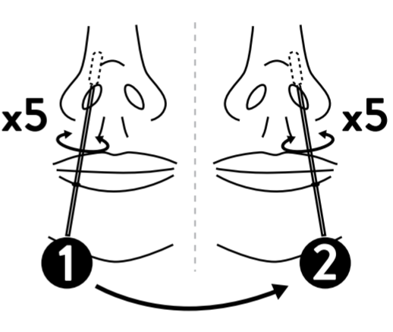
- Insert the swab specimen in the extraction tube. Swirl the swan tip in the buffer fluid you previously placed in the extraction tube, pushing it into the wall of the extraction tube at least five times and then squeeze out the swab by squeezing the extraction tube with your fingers.

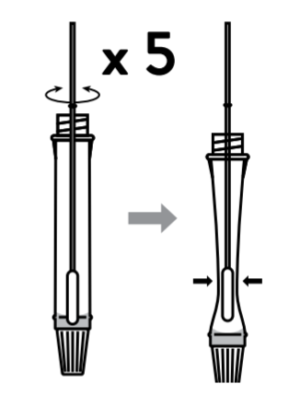
- Break the swab at the breakpoint and close the cap of extraction tube.

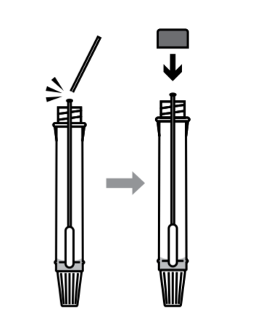

- Open the dropping nozzle cap at the bottom of the extraction tube.

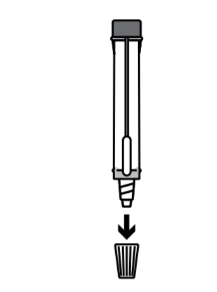

- Dispense 5 drops of extracted specimens vertically into the specimen well on the device. Do not handle or move the test device until the test is complete and ready for reading.
Caution! Bubbles that occur in the extraction tube can lead to inaccurate results. If you are unable to create sufficient drops, this may be caused by clogging in the dispensing nozzle. Shake
the tube gently to release the blockage until you observe free drop formation.
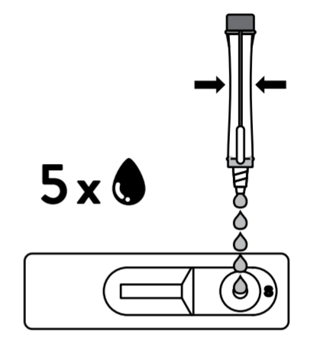

- Close the nozzle and dispose of the extraction tube containing the swab. All the items can go in general waste at home, regardless of results.

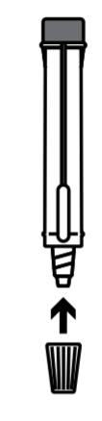

- Start timer. Read results at 15 minutes. Results read before 15 minutes or after 20 minutes are not considered valid.
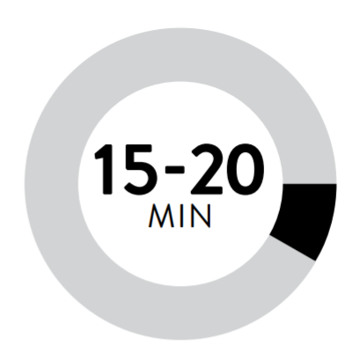

TEST INTERPRETATION

Negative: The presence of only the control line (C) and no test line (T) within the result window indicates a negative result.

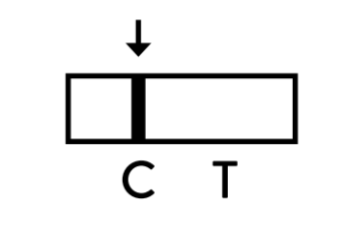

Positive: The presence of the test line (T) and the control line (C) within the result window, regardless of which line appears first, indicates a positive result.
The presence of any test line, no matter how faint, indicates a positive result.
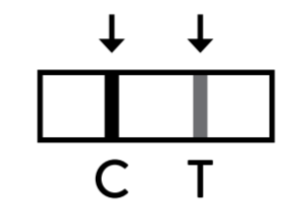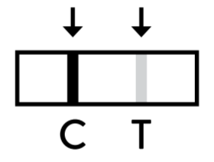
Invalid: If the control line (C) is not visible within the result window after performing the test, the result is considered invalid. Instructions may not have been followed correctly. It is recommended to re-test the specimen with a new test device.

What to do with test results

Once you have completed the test

- If result is negative, no further action required
- If test is positive, email ohn@ucalgary.ca with a picture of the test result.

References:
https://dam.abbott.com/en-gb/panbio/120007883-v1-Panbio-COVID-19-Ag-Nasal-AsymptomaticSe.pdf
Rapid antigen screening - YouTube

