YOUR STAY IN CALGARY, ALBERTA, CANADA
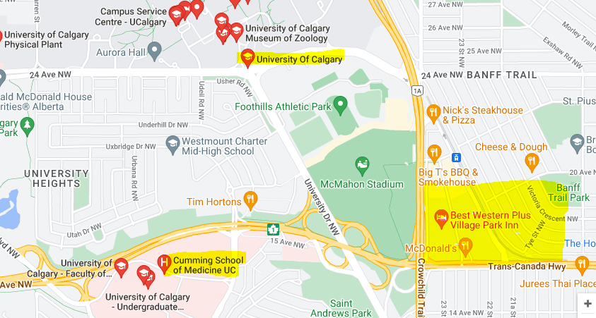

Conference will be held at the Cumming School of Medicine - 3280 Hospital Road NW, Calgary, Alberta, Canada T2N 4Z6
Award Dinner / March 18, 2023 (evening) will be held at MacEwan Hall – Cassio B Room / University of Calgary Main Campus: 2500 University Dr NW, Calgary, AB T2N 1N4
Hotels near us are:
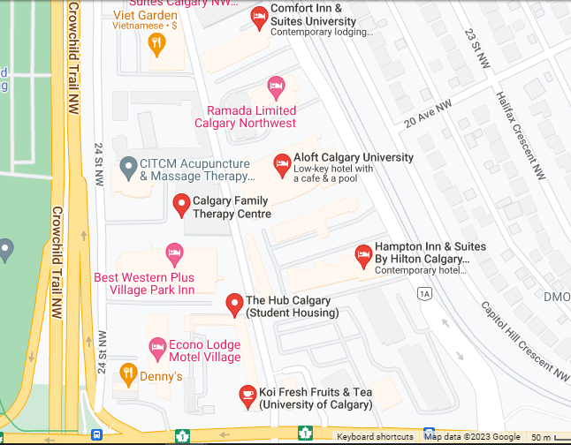

BEST WESTERN PLUS VILLAGE PARK INN
Address: 1804 Crowchild Trail NW, Calgary, AB T2M 3Y7
Phone: (403) 289-0241

HAMPTON INN & SUITES
Address: 2231 Banff Trail NW, Calgary, AB T2M 4L2
Phone: (403) 289-9800

ALOFT
Address: 2359 Banff Trail NW, Calgary, AB T2M 4L2
Phone: (403) 289-1973

RAMADA
Address: 2363 Banff Trail NW, Calgary, AB T2M 4L2
Phone: (403) 289-5571

ECONO LODGE
Address: 2440 16 Ave NW, Calgary, AB T2M 0M5
Phone: (403) 289-2561

TRANSPORT: If the weather is nice, walking from the hotels is an option, however it would still be a significant walk. We will have transit info at the event.

Check out info here:
https://www.ucalgary.ca/student-services/iss-old/resources/getting-around

