St. Petersburg
Developing supports for clients residing in sheltered housing as an alternative transition form, a model of psychosocial therapy and rehabilitation in hospital units, and a system of consistent collaboration with outpatient services in the service area

Ryazan
Developing support groups for people with psychiatric disorders and their families, and establishing a new short-stay Rehabilitation Centre with outpatient component and sheltered housing, and with linkages to community resources

Moscow: An early psychosis day clinic with a wide range of psychosocial interventions, and a variety of community services at Dispensary #14
Moscow Region: Developing psychosocial therapy and rehabilitation in hospital units for persons with long hospital stay, with further maintenance therapy in outpatient environment after the discharge

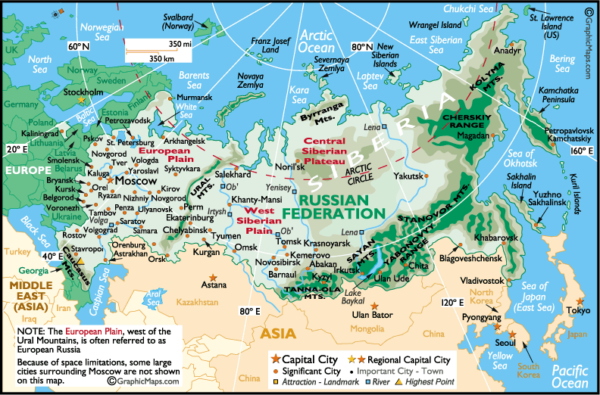

Stavropol Two demonstration model programs:
– an early psychosis clinic with a day program, and implementing psychosocial rehabilitation methods in hospital units, and
– establishing community based approaches to mental health and other services to refugees, forced migrants, and those suffering post-traumatic stress disorders

Omsk
Development of coordinated multi-profile services, including a group home for people with psychiatric disabilities, rehabilitation complex with a day program, an early psychosis clinic, a client club, and multi-professional team work in the out-patient environment.
Tambov:
An independent living program based on different forms of sheltered housing, developing employment options, psycho-education and communicative skill training, group supports for persons with psychiatric disorders and their families, and collaborative activities with the local social services

