

UNIT 11
Renal Function

Originally developed by:
Joyce Buzath RN, MN
Clinical Specialist, Renal
Foothills Hospital, Calgary

Revised (2000) by:
Marlene Reimer RN, PhD, CCN(C)
Associate Professor
Faculty of Nursing, University of Calgary
&
Associate in Nursing, Calgary Regional Health Authority
Unit 11 Table of Contents
Overview 4
Aim 4
Objectives 4
Resources 4
Web Links 4
Learning Activity #1—Pre-Test 5
Section 1: Renal Failure 8
Acute Renal Failure (ARF) 8
Chronic Renal Failure (CRF) 10
Learning Activity #2—Crossword Puzzle 18
Final Thoughts 20
References 21
Glossary 22
Acronym List 22
Checklist of Requirements 23
Answers to Learning Activities 24
Answers to Learning Activity #1—Pre-test 24
Answers to Learning Activity #2—Crossword Puzzle 25

UNIT 11
Renal Function

Renal function is an essential component in the maintenance of system homeostasis. Clients of all ages and health concerns may be faced with renal pathology which may lead to acute or chronic renal failure. This unit will enable you to more fully understand, assess, and intervene with renal concerns.

Overview

Aim
The aim of this unit is to help you think through what is happening at the cellular, organ, and system level during acute and chronic renal failure.

Objectives
By the end of this unit you will be able to:
- Differentiate between acute and chronic renal failure.
- Describe the etiology, pathophysiology and clinical manifestations of acute renal failure.
- Describe the etiology, pathophysiology and clinical manifestations of chronic renal failure.
- Describe the management of acute and chronic renal failure.

Resources


Requirements
Print Companion: Renal Function
Baer, C. (1990). Acute renal failure: Recognizing and reversing its deadly course. Nursing 90, 20(6), 34-40.
King, B. (1997). Preserving renal function. RN 60 (8), 34-40.
Porth, C. M. (2005). Pathophysiology-Concepts of Altered Health States (7th ed.). Philadelphia: Lippincott.
- Ch. 32, This chapter provides a review of the normal kidney structure and function. It is important to understand the structures of a nephron as this is essential to renal function.
- Chapter 35 provides a discussion on the disorders of renal function.
- Chapter 36 provides the discussion on the causes of renal failure.

- Supplemental Materials
Foothills Hospital, Calgary has excellent resources at the nursing library and on NU 27, as it is the renal unit for southern Alberta.
Stark, J. (1997). Dialysis choices: Turning the tide in acute renal failure. Nursing 97, 27,41-46.

Web Links
All web links in this unit can be accessed through the Web CT system.

Learning Activity #1—Pre-Test

As it may have been a while since you have studied renal anatomy and physiology, the following will assist you to “brush up”! be helpful to briefly review or to more fully explain the following questions. The answers can be found at the back of this unit. You will notice the relationship of this Unit to Unit 6.
- Commencing with Figure 32-4 p. 730 know the structures of the nephron.
Draw your own diagram if this is helpful to enhance your learning. It is crucial to understand the interrelationship of renal structures in order to understand renal function and alternation of function.
- What are the four major functions of the kidney?

- What are some products excreted by the kidneys?

- What does the normal kidney conserve that some diseased or immature kidneys do not?

- What four factors are involved in the regulation of body fluids?

- Name three hormones secreted by the kidney.

- What effect does antidiuretic hormone (ADH) have on urine concentration? Where and how does it act?

- What are the functions of the nephrons?

- What amount of blood flow do the kidneys require in order to optimize function?

- What is the minimum amount of urine output per hour of healthy kidneys?

- Define the following pathophysiological terms.
  - anuria

  - azotemia

  - hypoperfusion

  - oliguria

  - polyuria

  - uremia

  - uremic syndrome

Section 1: Renal Failure

Acute Renal Failure (ARF)

Adult ARF
Read:
- Baer (1990)
- King (1997)
- Porth (7th ed). Chapter 36

Pediatric ARF

Hemolytic Uremic Syndrome (HUS))
Read: Porth (7th ed.). Pages, 294, 354 and 901.
HUS is one of the most common causes of ARF in children (perhaps other than hypovolemia) (Newmann & Urizar, 1994). Children most often present to hospital with pyrexia, vomiting, abdominal pain, bloody diarrhea, decreased or no urine output, and perhaps bruising. In the initial stages, most parents believe that their child has the flu, but the onset of bloody diarrhea is the first clue that it is something more serious.

Pathophysiology
The etiology of HUS is not well understood, but is thought to be linked to an infectious response (Newmann & Urizar, 1994). HUS has been noted to be triggered by a toxic form of E-coli, in contaminated and poorly cooked meats. Other bacteria such as salmonella, shigella, and pseudomonas, as well as agents such as coxsackie and influenza viruses have also been implicated (Neumann & Urizar, 1994).
Pathophysiology reveals microangiopathy, in which the small blood vessels lose portions of their normally smooth endothelium. The red blood cells (RBC) become damaged by contact with the roughened intimal surface of the vessel and are rapidly destroyed. In the areas of endothelial damage, platelets adhere in such large quantities that thrombocytopenia rapidly develops. Due to the areas of local clotting in the arterioles, fibrin emboli are formed which may occlude the glomerular capillaries and may be responsible for the anuria.
A diagnosis is obtained through clinical and laboratory evaluation. Biopsies are not done in the initial stages of the disease due to high risk of bleeding (i.e., International Normalized Ratio (INR) for Prothrombin Time [PT] and partial Thromboplasten Time [PTT] are elevated.

Evaluation and Treatment
Dialysis needs to be commenced immediately due to the rapid onset of ARF and the accumulation of waste products from cell hemolysis is essential for fluid and electrolyte management. Peritoneal dialysis is the treatment of choice in infants and young children, as it is less invasive and traumatic than hemodialysis. Hemodialysis involves external blood circulation, and is difficult and dangerous for the pediatric population mainly due to their small blood volume. Hence, hemodialysis is used only in very acute situations. Plasmaphoresis is another treatment modality that may enhance recovery (Neumann & Urizar, 1994).
Other treatments for HUS may include administration of fluids, diuretics, parenteral nutrition, RBC, transfusions, and, steroid therapy to prevent damage to the endothelium, reduce platelet adhesion in the afferent arterioles and occlusion of glomeruli with fibrin plugs. Clinical treatment is similar to that of the adult, therefore it is not repeated here.
The prognosis is generally favourable, as long as early diagnosis and treatment occurs. Potential complications are hemorrhage, cardiac arrest (from hyperkalemia), or neurologic involvement (e.g., seizures, microthrombotic events, drowsiness, stroke). Renal function may be restored as long as dialysis is instituted, allowing the glomeruli and endothelium to heal, and the microangiopathy to resolve. Duration of dialysis may be over two to three days, or up to approximately ten days. Occasionally irreversible renal failure occurs due to irreversible nephron damage.
However, the greatest challenge with the pediatric population and their families is psychosocial support. The disease progresses very rapidly and hence treatment is implemented as quickly as possible. Rather than having flu, the child has a life threatening disorder with “high tech” treatment in a “high tech” environment. This situation can be most overwhelming for both the child and family.

ARF in Pregnancy
There are many normal changes that occur in the renal system during pregnancy (e.g., lengthening of the kidneys, dilation of the renal pelvis and ureter, increased glomerular filtration rate (GFR), and renal blood flow). Complications may occur if a pyelonephritis is untreated or becomes chronic.
ARF in pregnancy is rare, occurring in one of every 2000-5000 pregnancies. The type of ARF is related to the stage of pregnancy:
- Early pregnancy—associated with septic abortion and hypoperfusion related to hyperemesis.
- Late pregnancy—associated with Pregnancy Induced Hypertension (especially hypertensive encephalopathy) and hemorrhagic complications (again producing hypoperfusion).
- Prolonged intrauterine death may cause abnormal intravascular coagulation and precipitate ARF.

Treatment is related to the etiology, and in general is similar to other ARF cases. Dialysis (primarily hemodialysis) may be instituted more quickly however, as accumulating waste products need to be removed to provide a more normal fetal environment.
Additional renal complications in pregnancy:
If a preexisting renal condition such as diabetes mellitus or systemic lupus erythematosis (SLE) is present during pregnancy, the stress of pregnancy may exacerbate renal damage. This renal damage is often acute, and will resolve or its progression is controlled through close observation. Pathophysiology will relate to the specific disease process.

Chronic Renal Failure (CRF)
Read:

Porth (7th.ed). pp. 837-838.

Pathophysiology

Etiology
All of the following conditions may cause CRF.
- Developmental/congenital disorders
- 10% of newborns have malformations of the urinary tract

- Cystic disorders
- polycystic kidney disease (which is genetically inherited)

- Tubular disorders

- Neoplasms
- 85% of primary renal neoplasms are malignant. Metastasis indicates a poor prognosis
- Wilms’ tumor (a pediatric disorder which has a good prognosis)

- Infectious disease
- Pyelonephritis

- Glomerulonephritis (GN)
A general category, and the most common type of CRF. There are many types of this disease, but is always characterized by inflammation of the glomerulus. Seventy-five percent of all GN is caused by abnormal immune mechanisms.

- Obstructive disorders
- CRF occurs if the obstruction is not relieved before irreversible damage results

- Renal problems and systemic diseases
- diabetes mellitus
- hyperparathyroidism
- amyloidosis
- scleroderma
- Goodpasture syndrome
- systemic lupus erythematosus (SLE)
- nephrotic syndrome
- hypertensive nephropathy

- Toxic nephropathy
- analgesic nephropathy (for example prolonged use of ASA containing drugs)
- lead nephropathy

Theories of Pathophysiology
The pathophysiology of CRF is highly variable due to the great diversity of causes. However, two theories are currently used to explain general cellular effects.
- All Nephrons Affected
One theory suggests that all nephrons in specific areas may be affected (e.g., tubules, glomeruli, or vasculature). The degree of function lost, depends on which part of the nephron is affected. For example, if the tubular part of the nephron is damaged, the kidney would have difficulty equilibrating pH, sodium, and fluid levels.

- Intact Nephron Hypothesis
The intact nephron theory suggests that nephrons in a diseased kidney are either totally destroyed or functionally intact. The functionally intact nephrons contribute normally to excretion in proportion to their GFR.

Clinical Course
The clinical course of CRF progresses in three stages. Table 12.1 in this unit provides a summary of these three stages.
Table 12.1 Three Stages of CRF
Stage 1—Diminished Renal Reserve
- asymptomatic (normal electrolyte levels and urine volumes)
- homeostasis maintained
- renal biopsy indicates diminished renal function (25-60% function).

Stage 2—Renal Insufficiency
- increased serum blood urea nitrogen (BUN), creatinine (Cr)
- polyuria and/or nocturia
- anemia
- normal glomerular filtration rate (GFR)
- normal hormone secretion
- homeostasis maintained unless an insult is encountered such as hypovoleor exposure
- renal biopsy indicates diminished renal function (20-40% function).

Stage 3 - End Stage Renal Disease (ESRD)
- inability to maintain homeostasis
- excretory, regulatory and hormonal functions are severely impaired.
- development of uremia: increased BUN, increased Cr, anemia, hyperphosphatemia, hypocalcemia, hyperkalemia, metabolic acidosis, and usually hypervolemia related to oliguria.
- signs and symptoms: fatigue, anorexia, nausea and vomiting, hypothermia (normal temperature is approximately 36-36.5°Celsius), pruritus, neurological changes
- renal biopsy indicates less than 15% of normal function

Evaluation and Treatment
- Correct the cause (e.g., discontinue antibiotics, rehydrate)

- If end stage renal disease (ESRD) develops the following four treatments are available in Canada at this time:
  - Hemodialysis
  - Peritoneal Dialysis (PD)
  - Transplant
  - No Treatment

Hemodialysis
The external circulation of blood through an artificial, semipermeable membrane. Waste products are removed via diffusion, osmosis and ultrafiltration. Currently hemo-dialysis occurs for 3-4 hours, three times per week and may take place at home (client controlled), through limited care, or outpatient hospital dialysis. Figure 12.1 illustrates hemodialysis.
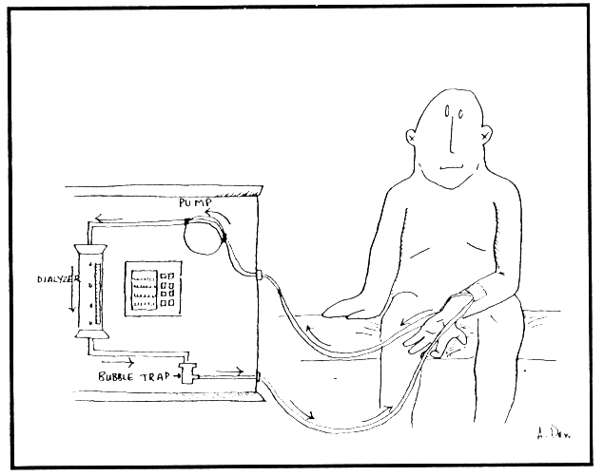
Figure 12.1 Hemodialysis

Peritoneal Dialysis (PD)
Metabolites are removed by using the peritoneal membrane as the dialysing “filter.” Fluid is introduced into the abdominal cavity via a surgically placed tubing and waste products are removed through diffusion, osmosis and ultrafiltration (same principles as hemodialysis). Current modes of peritoneal dialysis are: Continuous Ambulatory Peritoneal Dialysis (CAPD), Continuous Cycling Peritoneal Dialysis (CCPD), or Intermittent Peritoneal Dialysis (IPD). Figure 12.2 illustrates the principles and procedure of PD.
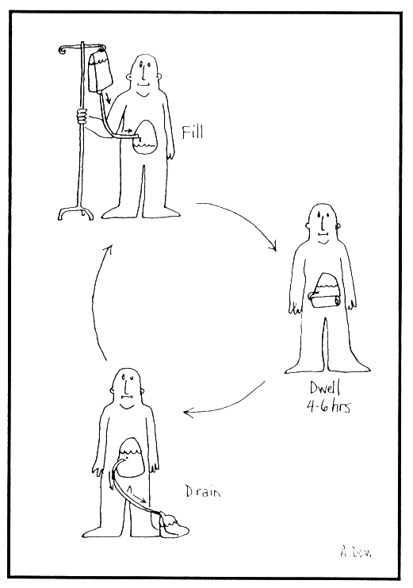
Figure 12.2 Peritoneal Dialysis
Adapted from: Smith, E. K. (1987). Renal disease: A conceptual approach. New York: Churchill-Livingstone.

Transplant
A kidney that is donated is surgically placed in either the left or right lower abdominal quadrant. The recipient must take anti-rejection drugs for the remainder of the transplant’s “life.” Figure 12.3 illustrates the position of a transplanted kidney.
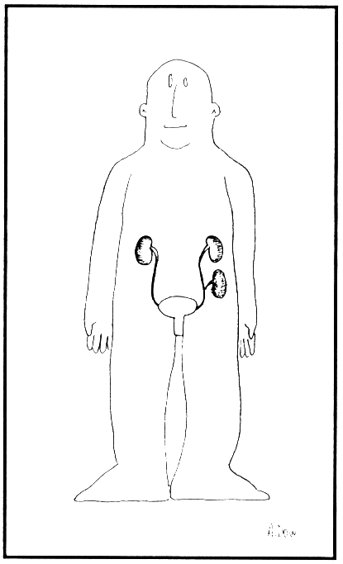
Figure 12.3 Transplant

No Treatment
Although this results in death, it is a viable alternative especially with malignant disease, or when quality life is no longer possible for the ESRD client (more common with multisystem disorders).

End Stage Renal Disease (Porth (7th ed.) pp. 839-40(ESRD) Case Study.
Due to the rapid changes and improvements in the diagnosis and treatment of ESRD, many complications that were once commonly seen, are now rare or only seen after the client has been on dialysis for a long period of time (> 5 years). However, when clients with CRF undergo surgery, or become ill, their inability to maintain homeostasis, necessitates close monitoring. This case study will present a typical client, who is commencing dialysis.
Joe is a 35 year old diagnosed as having diabetes mellitus since 13 years of age. He consistently follows his diet, monitors blood glucose levels, and is currently on insulin BID. His endocrinologist has noted, however, that Joe’s serum creatine (Cr) and blood urea nitrogen (BUN) are rising, and that there is protein in his urine. Twenty-four hour urine collections show that Joe’s Cr clearance is less than what it should be. A biopsy is not necessary in this situation as the results would not change the diagnosis or treatment of the disease processes.
Joe is currently in the stage of renal insufficiency. The source of the damage is the diabetes which is a chronic disease. The pathophysiology of CRF related to diabetes mellitus features:
- an increase of basement membrane-like material in the glomeruli
- the formation of nodular tissue (mesangial) which block and destroy glomeruli
- narrowing and thickening of small arteries in the nephron which produce ischemic changes

As the disease progresses to ESRD, Joe’s blood glucose will become more difficult to control (and he may be changed to QID insulin). Hypertension, edema, fatigue, nausea and/or vomiting, and other uremic symptoms will begin to occur. Medications such as diuretics, antihypertensives, pH buffers, and gastric medications (such as Maxeran or Gravol) assist to maintain homeostasis and prevent complications. A renal diet will be tailored for Joe that will entail restricted protein, sodium, potassium, phosphate, and perhaps fluid as well.
After much discussion with the nephrology team (nephrologist, nurses, social worker, and dietician), Joe decides to commence Continuous Ambulatory Peritoneal Dialysis (CAPD). A permanent, silastic catheter is placed in his abdomen in preparation for CAPD. He also has baseline tests conducted to be placed on the cadaver transplant list. Joe likes the concept of CAPD as he is in control of the dialysis. Although he is responsible for sterile bag changes four times per day, every day, he is able to be flexible with the timing and location of these changes. Once dialysis is commenced Joe’s medication may be decreased and his diet restrictions reduced, as dialysis will remove many of the nitrogenous and other waste products that were accumulating.
See Table 12.2 in this unit (following page) for differentiation between acute and chronic renal failure.
Table 12.2 Differentiation between Acute and Chronic Renal Failure
 | ARF | CRF
progression | sudden and rapid. Mortality rate is about 50% (Lancaster, 1990). Renal function is restored in survivors. | generally slow, asymptomatic, and irreversible. Mortality rate is 100% without treatment by dialysis or transplantation (Lancaster, 1990).
causes | hypoperfusion, nephrotoxins, and postrenal obstruction. | diabetes, immune disorders, hypertension.
stages | initiating, oliguric, diuretic, and recovery. | decreased renal reserve, renal insufficiency, and ESRD.
signs and  symptoms | vary and may be mild or extreme; oliguria or nonoliguria, azotemia or uremia. | initially mild (increase in serum Cr and BUN), and progress to uremia.
goal | maintain client (preventing life threatening complications such as sepsis or GI bleeding) to allow lesions to heal. | postpone ESRD as long as possible.
treatment | varies with etiology, but will include correction of underlying disorder(s) and conservative medical treatment. Aggressive dialysis treatment may be required. | varies with etiology, but will involve diet restriction, BP control, and medications. Onset of ESRD requires initiation of dialysis or transplantation and prevention of complications, or a decision for no treatment.

Learning Activity #2—Crossword Puzzle
The following crossword puzzle may be used as a post-test to determine your comprehension of alterations in renal function. Have fun! (Answers are at the back of this unit.)
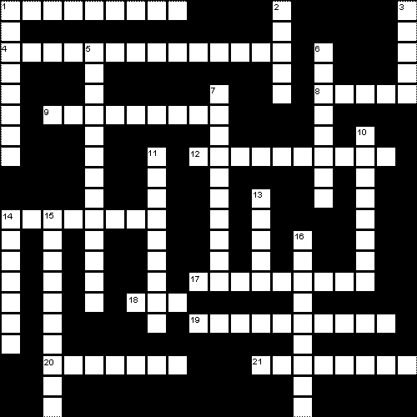

Clues  Across  1. A urethral obstruction may cause _____ ARF.  4. What renal hormone is involved in the formation of hemoglobin?  8. Rapid deterioration of kidney function may result in _____ renal failure.  9. Clinical indications of hypocalcemia are obtained through Chvostek’s and _____’s signs  12. One of the most common inherited kidney diseases is ________.  14. A urine output of < 499 ml/day is called _____.  17. ______ acidosis is common with CRF.  18. One type of pediatric ARF is _____.  19. Name a peripheral neurologic effect of uremia.  20. The individual unit of the kidney is known as the ______.  21. The most common systemic cause of CRF is ______. | Down  1. Inadequate (< 20% of cardiac output) renal blood flow may result in ______ failure.  2. Another term pertaining to the kidney is ______.  3. In ARF the kidney nephrons are damaged (e.g., acute tubular nephrosis). True or False?  5. Inadequate renal blood flow is called __________.  6. ARF may be managed conservatively or aggressively with ________.  7. ________ or antigen-antibody disorders cause most chronic glomerulonephritis.  10. The four phases of ARF are: onset, oliguric-anuric, ________ and convalescent.  11. CRF clients must limit their dietary intake of ________ to prevent possible cardiac problem.  13. Fluid overload is determined by measuring wt., BP, heart and lung sounds, and by the amount of ________.  14. Some foods that are high in potassium are bananas, baked potatoes and ________.  15. Glomerulonephritis is classified as a/an __________ problem.  16. The balance between calcium and ______ levels are important to control and prevent osteomalacia.

Final Thoughts
Renal disease is common end point for other acute and chronic conditions. By understanding the etiology and consequences of renal disease nurses can better appreciate the very important role they can play in prevention.
- primary (e.g., by protecting children from lead-based paints)
- secondary (e.g., through teaching and coaching of diabetics in maintenance of safe glucose levels)
- tertiary (e.g., by helping patients with chronic renal failure adhere to a diet that puts less demand on the failing kidneys)

References
Andrews, M., & Mooney, K. (1990). Alterations of renal and urinary tract function in children. In K. McCance & S. Huether (Eds.), Pathophysiology: The biologic basis for disease in adults and children (pp. 1217-1229). St. Louis: Mosby.
Baer, C. (1990). Acute renal failure: Recognizing and reversing its deadly course. Nursing 90, 20(6), 34-40.
Heates, D. W. (1999). If ADH goes out of balance: Diabetes insipidus. RN,62(7),42-49.
King, B. (1997). Preserving renal function. RN 60, (8), 34-40.
Neumann, M., & Urizar, R. (1994). Hemolytic uremic syndrome: Current pathophysiology and management. ANNA Journal, 21(2), 137-143.
Peterson, N. E., Schneider, R. E., & Wolfson, A. B. (1993). Treating acute anuria or oliguria. Patient Care, 27(1), 162-181.
Price, C. A. (1994). Acute renal failure: A sequelae of sepsis. Critical Care Nursing Clinics of North America, 6(2), 359-372.
Porth, C. M. (2005). Pathophysiology- Concepts of Altered Health States (7th ed.). Philadelphia: Lippincott.
Radke, K. J. (1994). The aging kidney: Structure, function, and nursing practice implications. ANNA Journal, 21(4), 181-192.
Smith, E. K. (1987). Renal disease: A conceptual approach. New York: Churchill Livingstone.
Stark, J. (1997). Dialysis choices: Turning the tide in acute renal failure. Nursing 97, 27,41-46.
Wiseman, K. C. (1991). Nephrotic syndrome: Pathophysiology and treatment. ANNA Journal, 18(5), 469-477.

Glossary
hemodialysis: The external circulation of blood through an artificial, semipermeable membrane.
peritoneal dialysis: Removal of metabolites by using the peritoneal membrane as the dialyzing filter.

Acronym List
ADH Anti-diuretic hormone
ARF Acute renal failure
BUN Blood urea nitrogen
CAPD Continuous ambulatory peritoneal dialysis
CCPD Continuous cycling peritoneal dialysis
Cr Creatinine
CRF Chronic renal failure
ESRD End stage renal disease
GI Gastrointestinal
GFR Glomerular filtration rate
GN Glomerulonephritis
HUS Hemolytic uremic syndrome
INR International Normalized Ratio (for reporting prothrombin time)
IPD Intermittent peritoneal dialysis
PD Peritoneal dialysis
PT Prothrombin time
PTT Partial thromboplastin time
RBC Red blood cells

Checklist of Requirements

❑ Learning Activity #1—Pre-test
❑ Read Print Companion: Renal Function
Read Porth (7th ed.). Chapter 32, 35, and 36.
❑ Read Baer (1990)
❑ Read King (1997)
❑ Learning Activity Crossword Puzzle

Answers to Learning Activities

Answers to Learning Activity #1—Pre-test

    - excretion of waste products of metabolism
    - conservation of essential substances
    - regulation of body fluid composition
    - secretion of hormones

- urea, nitrogen, creatinine, potassium, chloride, sodium, water.

- protein, glucose.

    - maintaining optimal volume/concentration of urine in relation to extra cellular fluid (ECF)
    - concentration of electrolytes in ECF
    - maintaining osmolarity of ECF
    - regulate acid-base balance (pH)

    - Renin
    - Erythropoetin [now available in synthetic form for treatment of End Stage Renal Disease (ESRD) induced anemia]
    - Vitamin D
    - ADH (Antidiuretic hormone)

- See McCance & Huether (2001), pp. 1184-1185.

- excretion and regulation by the processes of:
- glomerular filtration
- selective reabsorption of various tubule filtrate substances
- secretion of various substances into the filtrate by the tubule cells

- 1000-1200 ml/min. or 20-25% of cardiac output.

- at least 30 ml/hr (anything less indicates possible failure).

  - some sources state that anuria is complete cessation of urine formation by the kidney and others note that it is less than 50 ml per 24 hours
  - 1260
  - inadequate blood flow to and hence inadequate perfusion of the kidney that may result in acute renal failure (ARF)
  - p. 1236
  - excessive excretion of urine. This depends on fluid intake, but >3000 ml per day is considered abnormal
  - 1260
  - the group of (uremic) symptoms that arise as a result of kidney failure
Table 35-13, pp. 1210.

Answers to Learning Activity #2—Crossword Puzzle

Word List:  acute  autoimmune  diabetes  dialysis  diuretic  edema  erythropoietin  false | HUS  hypoperfusion  intrarenal  metabolic  neuropathy  nephron  oliguria  oranges | phosphate  postrenal  polycystic  potassium  prerenal  renal  Trousseau

