SharePoint Sites
Granting Permissions

Set up a group or use one that comes with your SharePoint site. By default your site will be set up with the following groups with specific permissions. It is easiest to use one of these groups; however you can set up your own if needed. The group name will be preceded by the name of your site.

- Members – can add, delete, edit
- Visitors – can see content but not do anything
- Viewers – can only see structure
- Owners – have full control

The advantage to using groups instead of adding individuals, is that permission changes are easier to handle: you apply permissions to the whole group instead of having to add it to each individual.

- Determine which level of access the person needs. Most project team members should be setup as Members.

- There are several ways to add users, but this is the safest as the permissions default to the group you have selected.
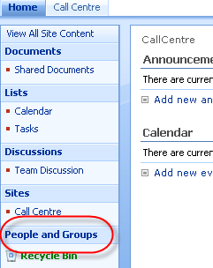
- Click People and Groups from the Quick Launch.

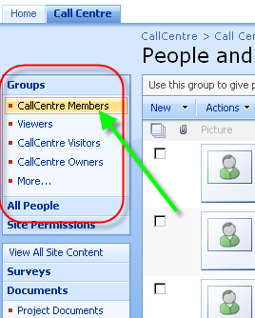
- Click the group name to which you are adding users (eg: Members)

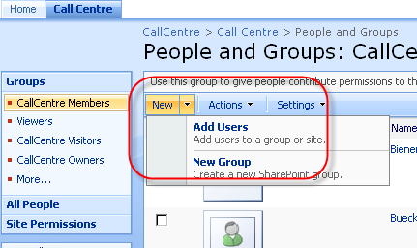
- Click New > Add users

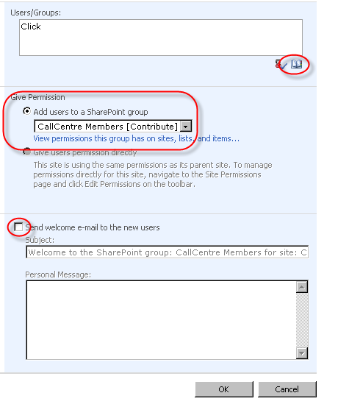
- The permission level will default to the name of the group you selected. > Click the Addressbook icon.

If the Send welcome e-mail to the new users box is checked, an email is sent to the new person. You can customize this message if desired in the Personal Message box. You can also de-select this option if you don’t want a message to go to the new person.

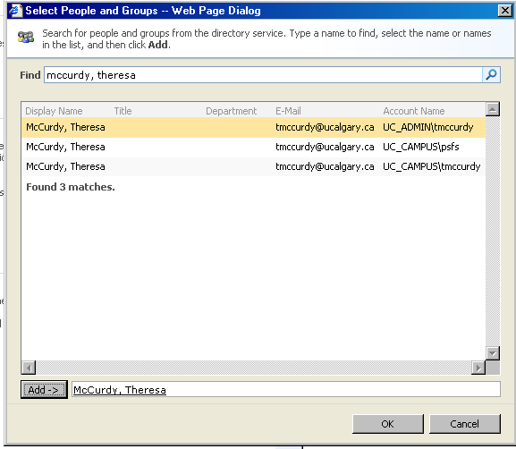
- Key the last name, first name of the user to add > Enter > select their account from the list that appears. It should always be the UC_ADMIN account. (If only a UC_CAMPUS account appears, you can select it.) > Click Add > Click OK

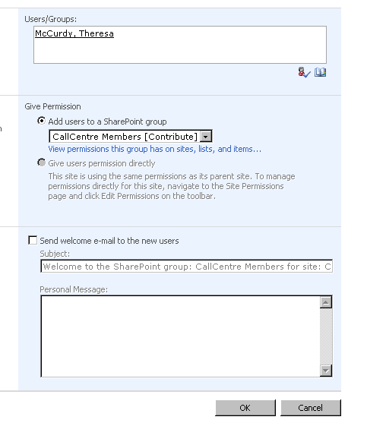
- The user’s name appears in the Users/Groups box. Repeat above step to add multiple users. When done adding users, click OK at the bottom of the screen.

- The user’s name appears in the list.

